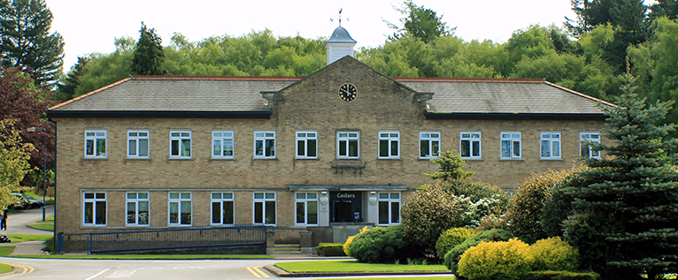
Case study:
Portland College
Portland College is a charitable independent specialist college for disabled learners aged 16+. They specialise in autism, physical and learning disabilities and acquired brain injuries.

Background
What is TechAbility?
Natspec launched the TechAbility service in March 2017 as a specialist Assistive Technology service, to improve outcomes for people with special educational needs (SEN) and disabilities in mainstream and specialist colleges and other provision.
Contact
Techability@natspec.org.uk
0115 854 1322
www.techability.org.uk

The TechAbility team visited Portland College following a request to provide clear guidance and to improve provision for students.
The Assistive Technologist met with Becky Cooper (Digital Engagement Vocational Lead), who was working to readdress training needs and improve the use of equipment within the Karten provision and across college.

TechAbility reviewed the assessment service and found that the staff were highly skilled and that there was a real opportunity to better link this expertise with learners. The key recommendation was that to improve this process through a collaborative and structured system.
Solution
We worked with Becky to develop an assessment process that involved staff across disciplines, recorded information effectively and helped learners access study, work and recreational activities. Additional plans were made to create Technology Champions and to produce a newsletter to share best practice and inspire staff.

We worked together with Portland College to procure equipment. This involved better sourcing the right tools to meet the learners’ needs – taking into consideration support and training. Carrying out this work helped to inform their Karten bid.

Becky was keen to take on several technologies that could assist students and requested access to further training. The webinars on dictation and whiteboards particularly suited their requirements. As these are recorded they can now be used by the college to train up their staff on-demand. Feedback from Becky showed that this was useful due to changing teams and a desire to upskill staff.

Finally, there were plans made to improve the Faith Area in the college, a fantastic space for learners; this includes talking switches and displays to ensure this space is more accessible and interactive, so learners can explore it independently.

